**Online Video 2012**

**Can You Afford To**

**Ignore It?**

**The Outlook For 2012 And Beyond**

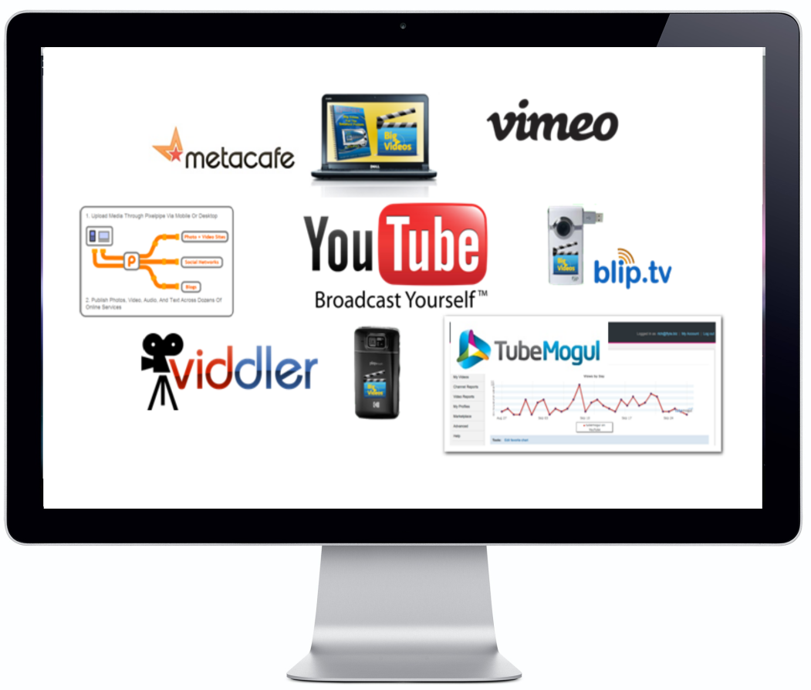

**[](http://bigvideosforyou.com/)**